FB post
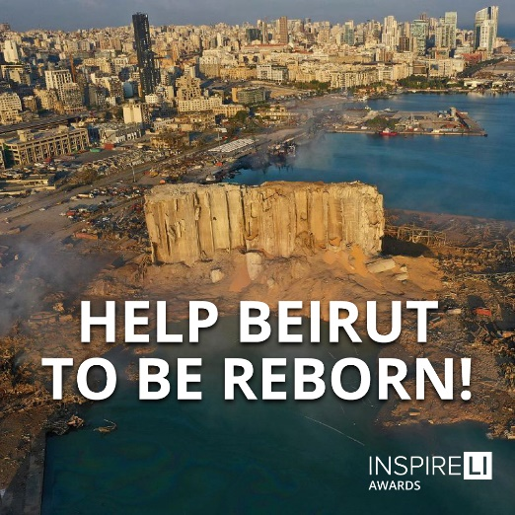
Our university is now part of the Inspireli family. You have a unique chance to help the Port of Beirut to be reborn after tremendous tragedy that occurred last year. Prepare your project and show the whole world your inspirative ideas, gain prestige and financial reward. Be part of the Inspireli Award project! Submit at: www.inspireli.com/cz/awards/beirut-documents

